**COSMETOLOGY SUPPORT**

**We are here to offer you 4 products for when you reopen for the safety of both you and your valued customer! Including 3-ply disposable masks, disposable gloves, a medical face shield, and 99% naturally derived hand sanitizer. One stop shop for all your needs!**

|  |  |  |
| --- | --- | --- |
| Item | Units | Price |
| Disposable Nitrile Gloves | 1 Box (50 pairs) | $32.00 |
| Disposable 3-Ply Face Masks | 1 Box (50 units) | $80.00 |
| Face Shield | 1 Face Shield | $8.60 |
| 100ml Hand Sanitizer | 1 Unit | $7.00 |
| 4L Hand Sanitizer | 1 Unit | $119.00 |

PACKAGE DEAL!

* 1 Box of 50 pairs of Disposable Gloves
* 1 Box of 50 Disposable Masks
* 1 Face Shield
* 5 bottles of 100ml Hand Sanitizer

Receive this package for $139.99 or 10% savings!

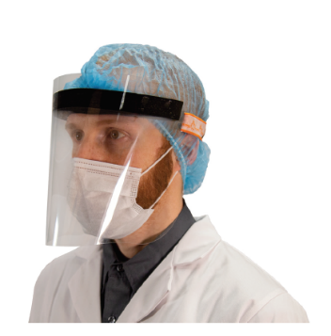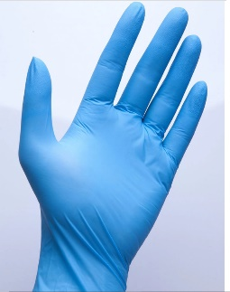Uniform Works Ltd. Dartmouth, NS B3B 0J5 902-468-5367 info@uniformworks.ca

www.uniformsworks.ca